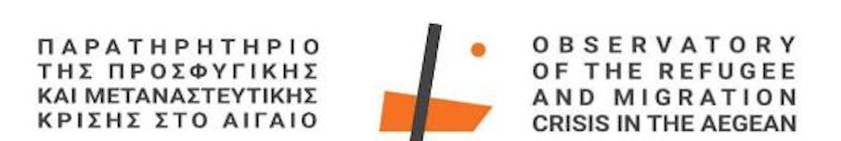

Press Release

From Sunday, May 19th to Wednesday, May 22nd, a group of academics from Université Côte d’Azur and the Observatory for Migrations and Societies (URMIS) visited the Observatory and Archive of the Refugee and Migration Crisis in the Aegean, the Department of Social Anthropology and History, and overall, the University of the Aegean in Lesvos.

The Université Côte d’Azur team included Yvan Gastaud (Associate Professor, Université Côte d’Azur), Swanie Potot (Research Director - National Center for Scientific Research - CNRS), Gulia Breda (Researcher, Université Côte d’Azur), Alban Fournier (CNRS - Administrative Support for International Research Projects), and artist and team collaborator Lena Merhej.
They were welcomed in Mytilene by representatives from the Observatory for the Refugee and Migration Crisis in the Aegean and DSAH: Emeritus Professor Efthymios Papataxiarchis, Assistant Professor Effie Plexousaki, and PhD candidate Nadina Leivaditi.
The visit was part of the ReMMi (Récits de Mobilités et des Migrations - Narratives of Mobility and Migration) research project, led by Yvan Gastaud and funded by Université Côte d’Azur and the CNRS branch in Nice.

The Observatory is participating in the research project on "The 2015 'Crisis' on the Aegean Islands and the Memory Among Refugees, Men and Women, from Afghanistan and Syria.
"The purpose of the visit was to collaborate with the scientific team of the University of the Aegean to organize a conference within the above research project, renew contact with the Department of Social Anthropology and History, and collaborate with members of Université Côte d’Azur and CNRS with the International Relations and Erasmus Department of the University of the Aegean to establish a cooperation agreement under the ReMMi project and explore further collaboration opportunities within the framework of university internationalization.

The team from Nice attended part of the PhD candidates' meeting at DSAH from May 18th to 22nd, interacted with members of humanitarian organizations providing shelter, education, legal, and psychosocial support to refugees and migrants in Lesvos, and exchanged ideas on administrative support aspects related to international university collaborations with Ms. Kontara, Head of the International Relations Department of the University of the Aegean, and Ms. Varkaraki, responsible for international student mobility under the Erasmus program.
Finally, the French team visited the Museum of Refugee Memory in Skala Loutron and the Petrified Forest Park and Museum in Sigri.

