Make your own collage

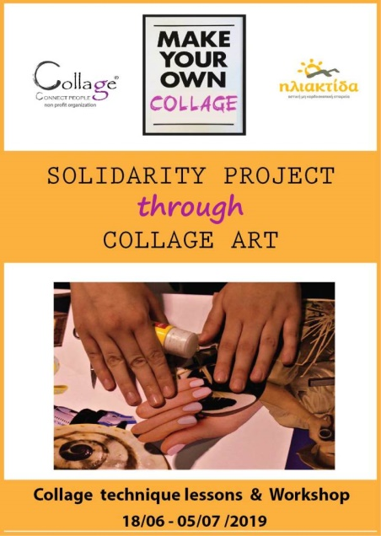

A Solidarity Project
A learning, artistic, visual and useful project aimed at minor refugees with the collaboration of Iliaktida amke and Collage Connect People (amke).

Duration: 3 weeks from 18 June to 5 July 2019

Place: Office of Iliaktida amke (1st week) - O.D.D Office (Office of Displaced Designers)

Methods of conducting: Speeches, videos, examples and workshops with material from Collage CONNECT PEOPLE collection, with the help of translators offered by Iliaktida amke.

PROGRAM OF ACTIONS

During the first week there will be courses on the theoretical approach of collage art, historical retrospection, when and how it appeared as an art movement, samples of important works by great painters, projections of examples of collage artwork. Also, references about the collage philosophy, and how to apply Gestalt theory to the handmade collage technique, focusing on the mental empowerment of participants as well as on the technique and use of materials and ways of choosing the photos.

During the second week , photographic material, separation on subjects, learning the technique of cutting and welding images and final synthesis of visual effect will be handled. Our aim is to create individual collage per participant.
During the third week we attempt to create a collective collage of more than 4 meters long. At the same time, groups of children will be collecting their works, scanning, canvas prints, make frames and decorate the children's living space.

It is an ambitious project that besides its visual result, the "journey" to the world of Art will have a greater value. Simultaneously, children will experience psychological empowerment , through the handmade collage technique . They will learn how to combine images and emotions in different environments. The project will also stimulate other artistic actions among young people from different countries.

This project aims to be a model for the approach of vulnerable social groups and a model for the enhancement of their creative occupation. Our ambition is to establish the project in Greece and other countries.

We greatly thank Office of Displaced Designers for space and support.
http://www.displaceddesigners.org/
More details about it
Fb pages Iliaktida amke + Collage connecting people also at site www.collage.gr

